## Practice Test 3

### **Question 1**

Unattempted

Domain :Describe AI workloads and considerations

What is the name of the common AI service that provides 24 by 7 monitoring of the customer's time-series data for possible data irregularities?

]A.

**Machine Learning**

]B.

**Anomaly Detection**

]C.

**Computer Vision**

]D.

**Natural Language Processing**

]E.

**Conversational AI**

]F.

**Automated Machine Learning**

**Explanation:**

**Correct Answer: B**

Customers are using Anomaly detection APIs for constant monitoring of their time-series data. Anomaly detection service ingests the data and automatically selects the best ML model for identification of the possible data irregularities. The service alerts the customers as soon as such anomalies arise.

Anomaly Detection is one of the five key elements of Microsoft Artificial Intelligence. The other four are Machine Learning, Computer Vision, Natural Language Processing and Conversational AI.

* **Options A, C, D, and E are incorrect**. Along with Anomaly detection, all these options are the key elements of Artificial Intelligence.
* **Options F is incorrect**. Automated Machine Learning is a feature of Machine Learning and is not part of Anomaly detection.

For more information about Anomaly Detection, please visit the below URL-

* <https://docs.microsoft.com/en-us/learn/modules/get-started-ai-fundamentals/3-understand-anomaly-detection>.

### **Question 2**

Unattempted

Domain :Describe AI workloads and considerations

What is the name of the responsible AI principle that directs AI solutions design to include resistance to harmful manipulation?

]A.

**Privacy and security**

]B.

**Transparency**

]C.

**Inclusiveness**

]D.

**Accountability**

]E.

**Reliability and safety**

]F.

**Fairness**

**Explanation:**

**Correct Answer: E**

Microsoft recognizes six principles of responsible AI.

Fairness, Reliability and safety, Privacy and security, Transparency, Inclusiveness and Accountability.

The principle of Reliability and safety directs AI solutions to respond safely to non-standard situations and to resist harmful manipulations.

All other options are incorrect.

For more information about guiding principles for responsible AI, please visit the below URLs-

* <https://www.microsoft.com/en-us/ai/responsible-ai?activetab=pivot1:primaryr6>
* <https://docs.microsoft.com/en-us/learn/modules/responsible-ai-principles/4-guiding-principles>

### **Question 3**

Unattempted

Domain :Describe fundamental principles of machine learning on Azure

Select all models that are part of Supervised ML?

A.

**Regression model**

B.

**Association**

C.

**Classification Model**

D.

**Clustering Model**

E.

**Anomaly Detection**

**Explanation:**

**Correct Answers: A and C**

A Regression and Classification modeling types are two parts of Supervised machine learning. Both techniques train the models using labeled data- previously acquired or historical data for the label.

* **Option B is incorrect** because Association belongs to Unsupervised machine learning. It establishes associations/relationships between data objects in large databases and uses data that is not labeled.
* **Option D is incorrect**. Clustering belongs to Unsupervised machine learning.
* **Option E is incorrect** because Anomaly Detection belongs to Unsupervised Learning. It detects the irregularities in the time series data and uses the data that is not labeled.

For more information about Supervised ML, please visit the below URLs-

* <https://azure.microsoft.com/en-us/overview/machine-learning-algorithms/#techniques>
* <https://www.guru99.com/supervised-vs-unsupervised-learning.html>

### **Question 4**

Unattempted

Domain :Describe fundamental principles of machine learning on Azure

You need to train and test your model. You prepare data for model training. Several of your numeric features have different scales- the first feature has a minimum value of 0.253 and a max of 0.987, the second one - from 12  to 124, and the last one - from 13545 to 56798. You need to bring them to a common scale.

You decide to normalize your data to address this problem.

Does this decision help you to achieve your goal?

]A.**Yes**

]B.**No**

**Explanation:**

**Correct Answer: A**

You need to normalize your numeric features. The process of normalization brings numeric features to a common scale.

For more information about Data Normalization, please visit the below URLs-

* <https://docs.microsoft.com/en-us/azure/machine-learning/algorithm-module-reference/normalize-data>

### **Question 5**

Unattempted

Domain :Describe fundamental principles of machine learning on Azure

What is the ideal value for AUC?

]A.

**2**

]B.

**0.5**

]C.

**0**

]D.

**0.1**

]E.

**1.0**

]F.

**O.75**

**Explanation:**

**Correct Answer: E**

Area Under Curve (AUC) is the model performance metrics for classification models. For binary classification models, the AUC value of 0.5 represents the random predictions. The model predictions are the same as randomly selected values of "Yes" or "No." If the AUC value is below 0.5, the model performance is worse than random. Ideally, the best-fitted model has a value of 1. Such an ideal model predicts all the values correctly.

For more information about AUC, please visit the below URLs-

* <https://docs.microsoft.com/en-us/learn/modules/create-classification-model-azure-machine-learning-designer/evaluate-model>

### **Question 6**

Unattempted

Domain :Describe fundamental principles of machine learning on Azure

What metrics does Azure ML use for the Evaluation of the regression models?

Select all that apply.

A.

**Root Mean Squared Error (RMSE)**

B.

**Accuracy**

C.

**Number of Points**

D.

**Mean Absolute Error (MAE)**

E.

**Combined Evaluation**

F.

**Coefficient of Determination**

G.

**Recall**

**Explanation:**

**Correct Answers: A, D and F**

Azure ML uses model evaluation for the measurement of the trained model accuracy. For regression models Evaluate Model module provides the following five metrics- Mean absolute error (MAE), Root mean squared error (RMSE), Relative absolute error (RAE), Relative squared error (RSE), and Coefficient of determination (R2).

* **Option A is correct**. Root Mean Squared Error (RMSE) is the regression model evaluation metrics. It represents the square Root from the squared mean of the errors between predicted and actual values.
* **Option D is correct**. Mean absolute error (MAE) is the regression model evaluation metrics. It produces the score that measures how close the model is to the actual values — the lower score, the better the model performance.
* **Option F is correct**. Coefficient of determination or R2 is the regression model evaluation metrics. It reflects the model performance: the closer R2 to 1 - the better the model fits the data.
* **Option B is incorrect**. Accuracy is the classification model evaluation metrics and is not the regression model evaluation metrics.
* **Option C is incorrect**. Number of Points is the clustering model evaluation metrics and is not the regression model evaluation metrics.
* **Option E is incorrect**. Combined Evaluation is the clustering model evaluation metrics and is not the regression model evaluation metrics.
* **Option G is incorrect**. Recall is the classification model evaluation metrics and is not the regression model evaluation metrics.

For more information about Azure ML evaluation of the regression models, please visit the below URLs-

* <https://docs.microsoft.com/en-us/learn/modules/create-regression-model-azure-machine-learning-designer/evaluate-model>
* <https://docs.microsoft.com/en-us/azure/machine-learning/algorithm-module-reference/evaluate-model>

### **Question 7**

Unattempted

Domain :Describe fundamental principles of machine learning on Azure

What are the three main authoring tools on the Azure ML Studio home screen?

A.

**Notebooks**

B.

**Datasets**

C.

**Designer**

D.

**Experiments**

E.

**Compute**

F.

**Automated ML**

G.

**Pipelines**

**Explanation:**

**Correct Answers:  A, C and F**

Azure ML Studio has three main authoring tools on its home page-

Notebooks, Automated ML and Designer.

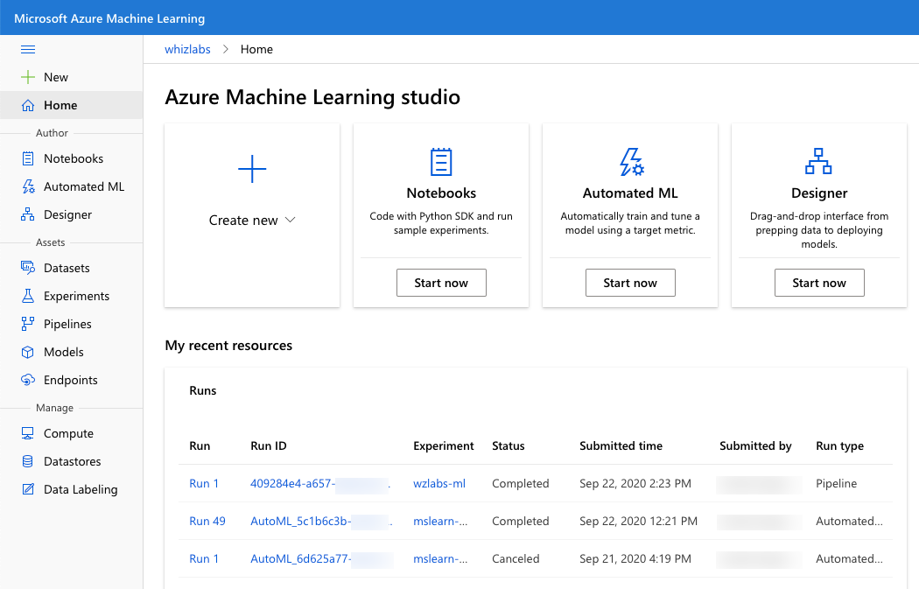

* **Option B is incorrect**. Datasets are part of Assets tools and are not part of authoring tools.
* **Option D is incorrect**. Experiments are part of Assets tools and are not part of authoring tools.
* **Option E is incorrect**. Compute is a part of Manage tools and is not the part of authoring tools.
* **Option G is incorrect**. Pipelines are part of Assets tools and are not part of authoring tools.

For more information about Azure ML Studio, please visit the below URL-

* <https://docs.microsoft.com/en-us/azure/machine-learning/overview-what-is-machine-learning-studio>

### **Question 8**

Unattempted

Domain :Describe features of computer vision workloads on Azure

Please select all examples of the Image classification technique applications.

A.

**Detecting tumors on X-ray images**

B.

**Recognizing text in images**

C.

**Visual product search**

D.

**Face recognition**

E.

**Disaster investigation**

F.

**Entity recognition**

**Explanation:**

**Correct Answers: A, C and E**

The Image classification model helps to classify images based on their content. This Computer vision technique helps doctors find cancer and other medical conditions on X-ray or MRI images. It supports visual product search and benefits disaster investigation by classifying engineering structures, like bridges, on aerial photos.

* **Option B is incorrect** because we use another Computer vision technique - Optical Character Recognition but not Image classification for text recognition in images.
* **Option D is incorrect** because we use another Computer vision technique - Face detection, but not Image classification for face detection and recognition.
* **Option F is incorrect** because the Entity recognition is Text Analytics service, and it doesn't use Image classification.

For more information about Image classification, please visit the below URL-

* <https://docs.microsoft.com/en-us/learn/modules/classify-images-custom-vision/1-introduction>.

### **Question 9**

Unattempted

Domain :Describe features of computer vision workloads on Azure

You have a picture with two cats in front of a car and a bus, and three trees in the background. How many classes will Semantic segmentation identify in this picture?

]A.

**3**

]B.

**4**

]C.

**7**

]D.

**5**

]E.

**8**

**Explanation:**

**Correct Answer: B**

Semantic segmentation is a Computer vision technique that identifies picture pixels with the classes. In the picture, we have the following four classes- "cat," "car," "bus," and "tree."

All other options are incorrect.

For more information about Semantic segmentation, please visit the below URLs-

* <https://docs.microsoft.com/en-us/learn/modules/get-started-ai-fundamentals/4-understand-computer-vision>
* <https://www.fritz.ai/image-segmentation/#:~:text=In%20semantic%20segmentation%2C%20each%20pixel,the%20same%20%E2%80%9Ccar%E2%80%9D%20class.>

### **Question 10**

Unattempted

Domain :Describe features of computer vision workloads on Azure

You are using Analyze image API to obtain image information. The API response includes a likelihood that the image is one of the two content types.

What are these types?

A.

**Color Picture**

B.

**Clip Art**

C.

**Photo**

D.

**Painting**

E.

**Line drawing**

F.

**Black and white picture**

**Explanation:**

**Correct Answers: B and E**

Analyze image is one of the Computer Vision services. It provides detailed information about the image content that includes visual feature types (categories, brands, color, adult content, etc.), details (celebrities and landscapes), language, etc. Analyze image API returns also the likelihood that the image belongs to one of the two content types- clip art or line drawing.

When the analyzed image’s content type is not one of these two types, both types' return value is 0.

All other options are incorrect.

For more information about Analyze image service, please visit the below URLs-

* <https://docs.microsoft.com/en-us/azure/cognitive-services/computer-vision/concept-detecting-image-types>
* <https://westcentralus.dev.cognitive.microsoft.com/docs/services/computer-vision-v3-ga/operations/56f91f2e778daf14a499f21b>

### **Question 11**

Unattempted

Domain :Describe features of Natural Language Processing (NLP) workloads on Azure

You are using Text Analytics Entity Recognition API to analyze the following sentence- "After Peter met Sara at Microsoft headquarters in Paris, they visited the Eiffel tower."

How many entities with the category "Location" should you expect in the API response?

]A.

**0**

]B.

**1**

]C.

**2**

]D.

**3**

]E.

**4**

**Explanation:**

**Correct Answer: D**

Named Entity Recognition (NER) is a Text Analytics service that helps identify entities in the text and group them into different entity categories, like person, organization, location, event, etc.

You should expect three recognized named entities with the category "Location" in the API response- "headquarters," "Paris," and "Eiffel tower."

All other options are incorrect.

For more information about Entity Recognition services, please visit the below URLs-

* <https://docs.microsoft.com/en-us/learn/modules/analyze-text-with-text-analytics-service/2-get-started-azure>

### **Question 12**

Unattempted

Domain :Describe features of Natural Language Processing (NLP) workloads on Azure

What are the four resources that you need to use to call Text Analytics API endpoint?

A.

**recognize**

B.

**keyphrases**

C.

**translate**

D.

**entities**

E.

**languages**

F.

**detect**

G.

**sentiment**

**Explanation:**

**Correct Answers: B, D, E, and G**

Text Analytics is a part of Natural Language Processing. It includes the following services.

Sentiment analysis, Key phrase extraction, Entity recognition, and Language detection.

When you make a Text Analytics API call, you use the following expressions for each of the services, for example, if your Cognitive services are in the West US region-

* [https://westus.api.cognitive.microsoft.com/text/analytics/v3.0/](https://westus.api.cognitive.microsoft.com/text/analytics/v3.0/sentiment)[**sentiment**](https://westus.api.cognitive.microsoft.com/text/analytics/v3.0/sentiment)
* [https://westus.api.cognitive.microsoft.com/text/analytics/v3.0/](https://westus.api.cognitive.microsoft.com/text/analytics/v3.0/keyPhrases)[**keyPhrases**](https://westus.api.cognitive.microsoft.com/text/analytics/v3.0/keyPhrases)
* [https://westus.api.cognitive.microsoft.com/text/analytics/v3.0/](https://westus.api.cognitive.microsoft.com/text/analytics/v3.0/languages)[**languages**](https://westus.api.cognitive.microsoft.com/text/analytics/v3.0/languages)
* [https://westus.api.cognitive.microsoft.com/text/analytics/v3.0/](https://westus.api.cognitive.microsoft.com/text/analytics/v3.0/entities/recognition/general)[**entities**/recognition/general](https://westus.api.cognitive.microsoft.com/text/analytics/v3.0/entities/recognition/general)

All other options are incorrect.

For more information about Text Analytics API, please visit the below URL:

* <https://docs.microsoft.com/en-us/azure/cognitive-services/text-analytics/how-tos/text-analytics-how-to-call-api>.

### **Question 13**

Unattempted

Domain :Describe features of conversational AI workloads on Azure

You need to make your organization's auto phone attendant to read telephone voice menus in humanlike voices. You decided to use the Standard voice for your solution.

Does this decision help you to achieve your goal?

]A.**Yes**

]B.**No**

**Explanation:**

**Correct Answer: B**

Azure Text-to-Speech service provides two options for the voice- Standard and Neural. The Neural voice utilizes deep neural networks for Speech Synthesis and makes output sounds very close to humans. It reduces listening fatigue when people interact with automated attendants.

For more information about Azure Text-to-Speech service, please visit the below URLs-

* <https://docs.microsoft.com/en-us/azure/cognitive-services/speech-service/text-to-speech>

### **Question 14**

Unattempted

Domain :Describe features of conversational AI workloads on Azure

What are the examples of Conversation AI services?

Please select all that apply.

A.

**Online chat application**

B.

**Phone answering machine**

C.

**Web chat AI agent**

D.

**Email service**

E.

**A smart home device that can answer questions and act on commands**

F.

**Text messaging service**

**Explanation:**

**Correct Answers: C and E**

Azure Conversation AI supports agents, or bots, that can keep a conversation in turns with the users. Examples of such systems are Webchat AI agents, or bots, and Smart home devices that can answer your questions and act on your commands.

All other options are incorrect because they don't involve Conversation AI agents in their general implementation.

For more information about Conversation AI agents, please visit the below URLs-

* <https://docs.microsoft.com/en-us/learn/modules/build-faq-chatbot-qna-maker-azure-bot-service/1-introduction>

### **Question 15**

Unattempted

Domain :Describe features of conversational AI workloads on Azure

The customer service of your company spends a lot of time answering the same questions. They asked you to help them to automate this process. They provided you a Microsoft Excel (*.xlsx) document with frequently asked questions and typical answers. What service will you use to create a knowledge base from this document?

]A.

**Azure Bot Service**

]B.

**Custom vision**

]C.

**Text Analytics**

]D.

**QnA Maker**

]E.

**LUIS**

**Explanation:**

**Correct Answer: D**

You need to use the QnA Maker service. First, you need to provision the QnA Maker resource in your Azure subscription. After that, you can populate the newly created knowledge base using frequently asked questions (FAQ) document.

* **Option A is incorrect**. Azure Bot Service facilitates access to the knowledge base, but this service doesn't create a knowledge base.
* **Option B is incorrect**. Custom vision service helps create your computer vision model, but this service doesn't create a knowledge base.
* **Option C is incorrect**. Text Analytics helps analyze text documents, detect document's language, extract key phrases, determine entities, and provide sentiment analysis. But this service doesn't create a knowledge base.
* **Option E is incorrect**. Language Understanding Intelligent Service (LUIS) helps understand voice or text commands. But this service doesn't create a knowledge base.

For more information about QnA Maker, please visit the below URLs-

* <https://docs.microsoft.com/en-us/azure/cognitive-services/qnamaker/concepts/plan>
* <https://docs.microsoft.com/en-us/azure/cognitive-services/QnAMaker/quickstarts/create-publish-knowledge-base>

### **Question 16**

Unattempted

Domain :Describe AI workloads and considerations

What are NOT the main features and capabilities of Computer vision?

Please select all options that apply.

A.

**Anomaly Detection**

B.

**Image classification**

C.

**Automated machine learning**

D.

**Object Detection**

E.

**Text Analytics**

F.

**Semantic segmentation**

G.

**Optical character recognition**

**Explanation:**

**Correct Answers: A, C, and E**

 Microsoft Computer vision includes six features and capabilities.

* **Image classification** helps analyze images and video, detect objects and text, extract descriptions, and create tags.
* **Object detection** helps to identify objects and their boundaries within the image.
* **Semantic segmentation** helps classify pixels to the objects they belong to.
* **Image analysis** helps extract information from the images, tag them, and create a descriptive image summary.
* **Face detection, analysis, and recognition** help with detection, analysis, and recognition of human faces.
* **Optical character recognition** helps detect and recognize text in images and documents.

* **Options A is correct.** Anomaly Detection is one of the key elements of Artificial Intelligence, and it is not a feature of Computer vision.
* **Option C is correct**. Automated machine learning is one of the Machine Learning features and is not a feature of Computer vision.
* **Options E is correct**. Text Analytics is a feature of Natural language processing and is not a feature of Computer vision.

All other options are Computer vision features.

For more information about the features and capabilities of Computer vision, please visit the below URL-

* <https://docs.microsoft.com/en-us/learn/modules/get-started-ai-fundamentals/2-understand-machine-learn>.

### **Question 17**

Unattempted

Domain :Describe AI workloads and considerations

What are Azure Cognitive services that you can use to build Conversation AI solutions?

Please select all options that apply.

A.

**Text Analytics**

B.

**QnA Maker**

C.

**LUIS**

D.

**Object Detection**

E.

**Azure Bot Service**

F.

**Speech**

**Explanation:**

**Correct Answers: B and E**

Conversation AI is one of the key elements for Artificial Intelligence. It includes two services.

* **QnA Maker** helps create a knowledge base that serves as a foundation for a conversation between humans and AI agents.
* **Azure Bot Service** helps to create, publish, and manage Conversation AI agents, or bots.
* **Option A is incorrect**. Text Analytics is one of the NLP services that helps analyze text documents. It is not a Conversation AI solution.
* **Option C is incorrect**. LUIS is one of the NLP services that understands voice or text commands. It is not a Conversation AI solution.
* **Option D is incorrect**. Object Detection is one of the common tasks of Computer Vision that helps recognize objects on the images. It is not a Conversation AI solution.
* **Option F is incorrect**. Speech is one of the NLP services that helps recognize and synthesize speech. It is not a Conversation AI solution.

For more information about Conversation AI, please visit the below URL-

* <https://docs.microsoft.com/en-us/learn/modules/build-faq-chatbot-qna-maker-azure-bot-service/1-introduction>.

### **Question 18**

Unattempted

Domain :Describe AI workloads and considerations

What is the example of the responsible AI Privacy and security principle when users are running an AI solution from their devices?

]A.

**Secure data from the devices on the server where the model runs**

]B.

**Providing statement about the use of data**

]C.

**Deleting the data on the servers after model run**

]D.

**Running models on the device without removing any data**

]E.

**Checking the data on vulnerabilities**

**Explanation:**

**Correct Answer: D**

Microsoft recognizes six principles of responsible AI.

Fairness, Reliability and safety, Privacy and security, Transparency, Inclusiveness and Accountability.

The privacy and security principle defines that personal information and data must always be secure and kept private. If users run an AI solution on their devices, models should run on their devices and use their data. Data should stay on the device and not be moved to the server for this operation.

All other options are incorrect.

For more information about guiding principles for responsible AI, please visit the below URLs-

* <https://www.microsoft.com/en-us/ai/responsible-ai?activetab=pivot1:primaryr6>
* <https://docs.microsoft.com/en-us/learn/modules/responsible-ai-principles/4-guiding-principles>

### **Question 19**

Unattempted

Domain :Describe AI workloads and considerations

What does additional configuration reflect the responsible AI Transparency principle when creating a new Automated ML run in Azure ML Studio?

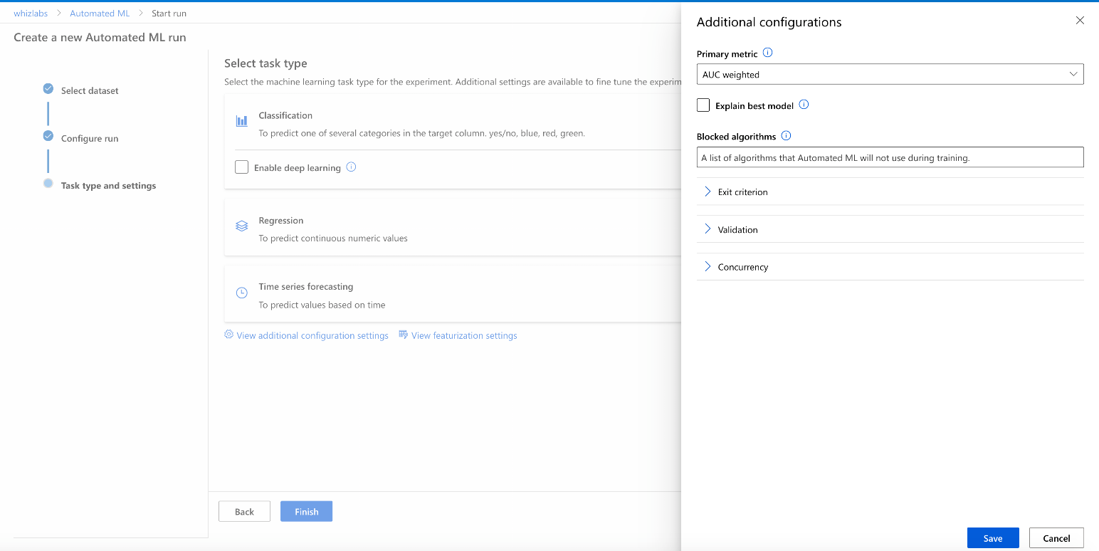

]A.

**Enable Deep Learning**

]B.

**Explain best model**

]C.

**Exit criterion**

]D.

**Validation**

]E.

**Concurrency**

**Explanation:**

**Correct Answer: B**

Microsoft recognizes six principles of responsible AI.

Fairness, Reliability and safety, Privacy and security, Transparency, Inclusiveness and Accountability.

The Transparency principle helps people understand how to use an AI solution, its behavior, possibilities, and limitations.

By selecting the "Explain best model" option, we are imposing an AI solution to be transparent and provide the logic and reasoning for choosing the best model.

All other options are incorrect.

For more information about guiding principles for responsible AI, please visit the below URLs-

* <https://www.microsoft.com/en-us/ai/responsible-ai?activetab=pivot1:primaryr6>
* <https://docs.microsoft.com/en-us/learn/modules/responsible-ai-principles/4-guiding-principles>

### **Question 20**

Unattempted

Domain :Describe fundamental principles of machine learning on Azure

Please select all examples of Classification models.

A.

**Predicting stock price based on earnings report**

B.

**Bank's assessment of the customer ability to pay back the loan**

C.

**Defining marketing groups by similar buying habits**

D.

**Monitoring time-series data for supervised anomaly detection**

E.

**Predicting the score of the game**

F.

**Reading text in images**

**Explanation:**

**Correct Answers: B, D and F**

The Classification is a Machine Learning form that predicts the category or class of the label. The classification model belongs to Supervised ML learning. It trains the models using previously acquired or historical data for the label.

* **Option B is correct** because, for the bank's assessment, you need to create a Classification model that, based on historical data, defines classes or categories for the customers' ability to pay back the loan, like "yes" or "no" categories.
* **Option D is correct** because, for supervised anomaly detection, you need to create a Classification model that, based on historical data, defines "normal and "abnormal" classes or categories for detecting the data irregularities in time-series data.
* **Option F is correct** because we need to use Optical Character Recognition (OCR) technique for reading text in images. OCR utilizes a multi-class Classification model.
* **Option A is incorrect** because you need to use a Regression Machine Learning model for a numeric prediction (stock price) but not a Classification model.
* **Option C is incorrect** because you need to use a Clustering Machine Learning model for grouping buyers based on their buying habits but not a Classification model.
* **Option E is incorrect** because you need to use a Regression Machine Learning model for a numeric prediction (game score) but not a Classification model.

For more information about Classification ML, please visit the below URL-

* <https://docs.microsoft.com/en-us/learn/modules/create-classification-model-azure-machine-learning-designer/introduction>.

### **Question 21**

Unattempted

Domain :Describe fundamental principles of machine learning on Azure

You created a classification model. Below is the confusion matrix for this model.

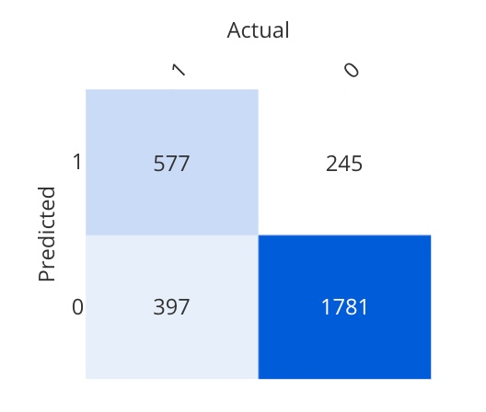

What is the expression for model Precision value calculation?

]A.

**577/(577+397)**

]B.

**(577+1781)/(577+245+397+1781)**

]C.

**577/(577+245)**

]D.

**397/(397+577)**

]E.

**1781/(1781+245)**

**Explanation:**

**Correct Answer: C**

The confusion matrix (or error matrix) provides a tabulated view of predicted and actual values for each class. It is usually used as a performance assessment for classification models.

A binary confusion matrix is divided into four squares that represent the following values.

* True positive (TP) — the number of positive cases that the model predicted right.
* True negative (TN) — the number of negative cases that the model predicted right.
* False positive (FP) — the number of positive cases that the model falsely predicted right.
* False negative (FN) — the number of negative cases that the model falsely predicted right.

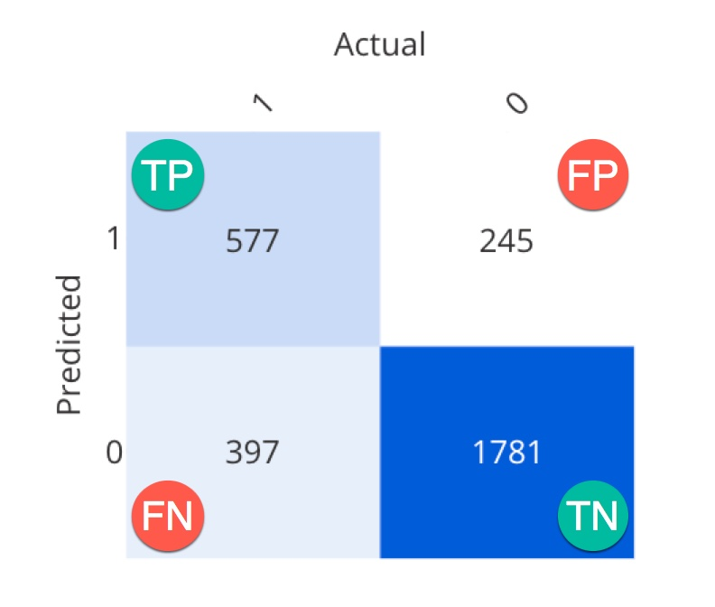

**Precision** metric defines how many positive cases are actually predicted right. We can calculate this metric using the following formula: TP/(TP+FP). Or in case of this task: **577/(577+245)** = 0.702 (Number 2).

* **Option A is incorrect**. This expression is for Recall metric calculation: TP/(TP+FN) or **577/(577+397)** = 0.592 (Number 3).
* **Option B is incorrect**. This expression is for Accuracy metric calculation: (TP+TN)/Total number of cases or **(577+1781)/(577+245+397+1781)** = 0.786 (Number 1).
* **Option D is incorrect**. This expression is for False negative rate metric calculation: FN/(FN+TP) or **397/(397+577)** = 0.408.
* **Option E is incorrect**. This expression is for Selectivity (or true negative rate) metric calculation: TN/(TN+FP) or **1781/(1781+245)** = 0.879.

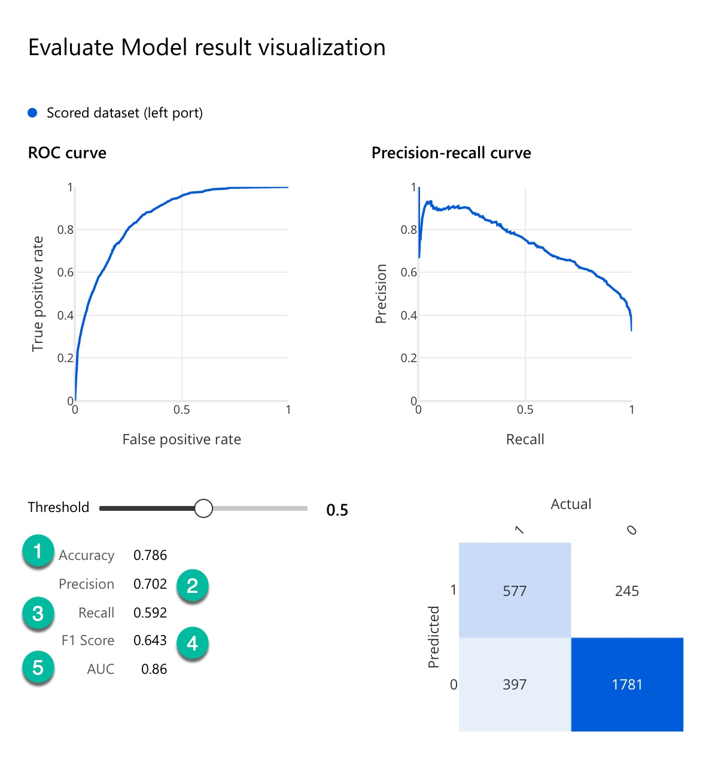

For more information about the Confusion matrix, please visit the below URLs-

* <https://docs.microsoft.com/en-us/learn/modules/create-classification-model-azure-machine-learning-designer/evaluate-model>
* <https://docs.microsoft.com/en-us/azure/machine-learning/how-to-understand-automated-ml#confusion-matrix>.

### **Question 22**

Unattempted

Domain :Describe fundamental principles of machine learning on Azure

You created a classification model. Below is the confusion matrix for this model.



What is the name of the metric that uses TP/(TP+FN) expression for its value calculation?

]A.

**Accuracy**

]B.

**Precision**

]C.

**Recall**

]D.

**F1 Score**

]E.

**Selectivity**

**Explanation:**

**Correct Answer: C**

The confusion matrix (or error matrix) provides a tabulated view of predicted and actual values for each class. It is usually used as a performance assessment for classification models.

A binary confusion matrix is divided into four squares that represent the following values.

* True positive (TP) — the number of positive cases that the model predicted right.
* True negative (TN) — the number of negative cases that the model predicted right.
* False positive (FP) — the number of positive cases that the model falsely predicted right.
* False negative (FN) — the number of negative cases that the model falsely predicted right.



**Recall**metric defines how many positive cases that the model predicted are actually predicted right. We can calculate this metric using the following formula:  TP/(TP+FN).

* **Option A is incorrect**. A formula for Accuracy metric calculation is (TP+TN)/Total number of cases.
* **Option B is incorrect**. A formula for Precision metric calculation is TP/(TP+FP).
* **Option D is incorrect**. A formula for F1 metric calculation is 2TP/(2TP+FP+FN).
* **Option E is incorrect**. This expression is for Selectivity (or true negative rate) metric calculation: TN/(TN+FP).

For more information about the Confusion matrix, please visit the below URLs-

* <https://docs.microsoft.com/en-us/learn/modules/create-classification-model-azure-machine-learning-designer/evaluate-model>
* <https://docs.microsoft.com/en-us/azure/machine-learning/how-to-understand-automated-ml#confusion-matrix>.

### **Question 23**

Unattempted

Domain :Describe fundamental principles of machine learning on Azure

What are the two data sources for the Import Data module in the Azure ML Designer?

A.

**Split data**

B.

**Datastore**

C.

**Local files**

D.

**URL via HTTP**

E.

**Open Datasets**

F.

**Azure SQL Database**

**Explanation:**

**Correct Answers: B and D**

There are only two ways to bring data into the Import module in the Azure ML designer- by Datastore and by URL via HTTP.

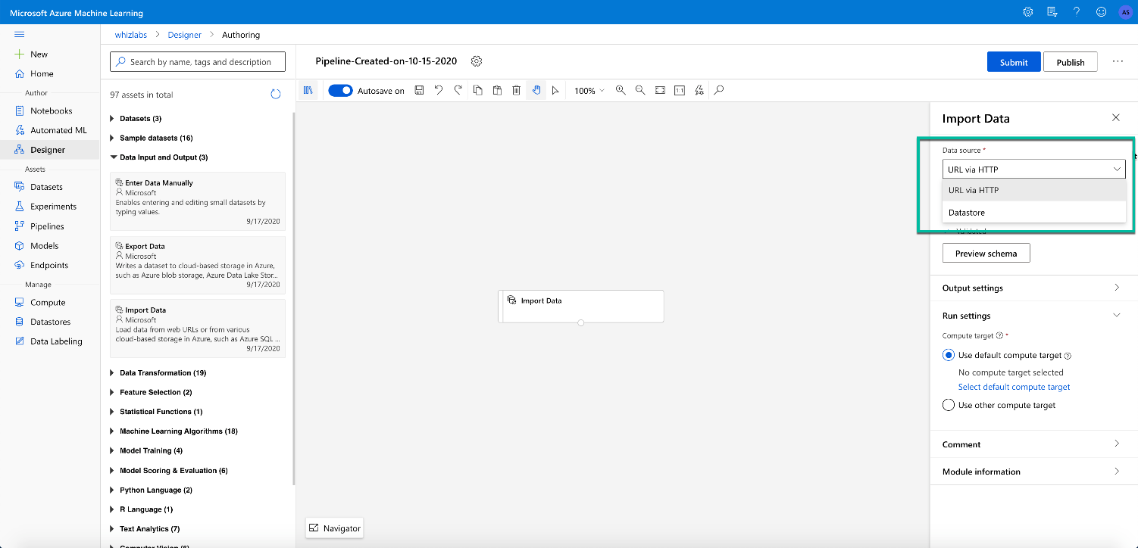

Datastore allows us to import data from several sources that you need to select as a type during Datastore registration including Azure SQL Database.

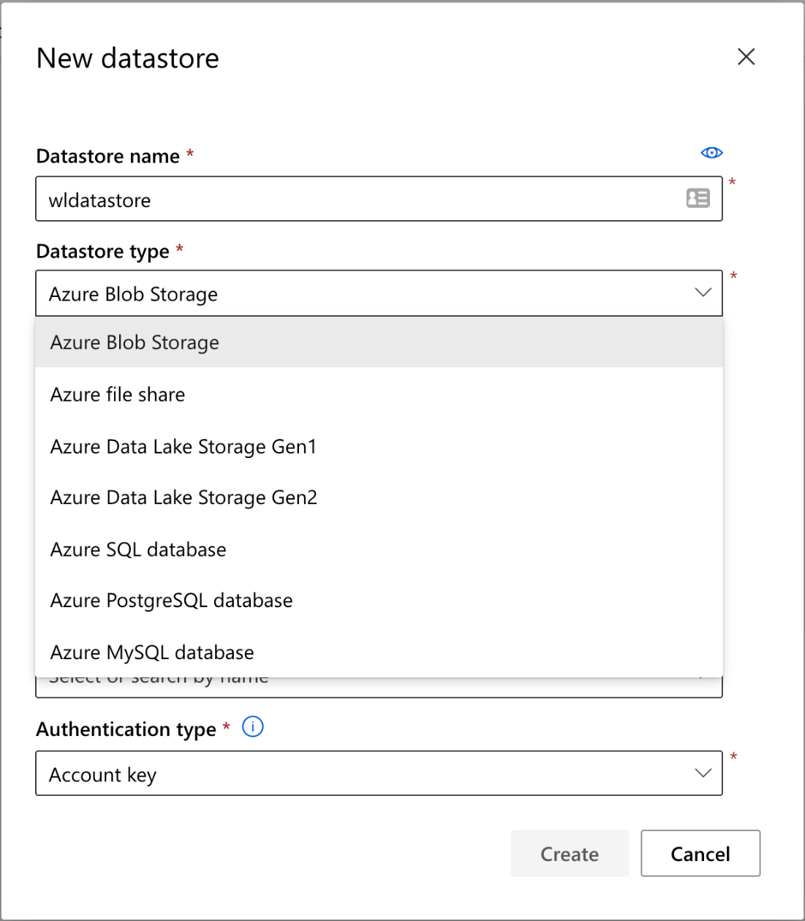

* **Option A is incorrect** because Split Data is a Data Transformation module of Azure ML Designer and is not the source for the Import data module.
* **Option C is incorrect** because Local files are the source for Datasets creation. After you created a dataset, for example, by importing data from the local files, you can select this dataset in the Designer as a data source instead of the Import data module.
* **Option E is incorrect** because Open datasets are the source for Datasets creation. After you created a new dataset, for example, by importing data from the Open datasets, you can select this dataset in the Designer as a data source instead of the Import data module.
* **Option F is incorrect** because Azure SQL Database is not the option for Import Data Source selection. However, you can register and select a new Datastore that has Azure SQL Database as a Type, and then use this Datastore as an Import Data source.

For more information about Azure ML Designer Import Data Module, please visit the below URL-

* <https://docs.microsoft.com/en-us/azure/machine-learning/algorithm-module-reference/import-data>.

### **Question 24**

Unattempted

Domain :Describe fundamental principles of machine learning on Azure

What metrics does  Azure ML use for the evaluation of the classification models?

Select all that apply.

A.

**Root Mean Squared Error (RMSE)**

B.

**Accuracy**

C.

**Number of Points**

D.

**Precision**

E.

**Combined Evaluation**

F.

**Coefficient of Determination**

G.

**Recall**

**Explanation:**

**Correct Answers: B, D and G**

Azure ML uses model evaluation for the measurement of the trained model accuracy. For classification models, the Evaluate Model module provides the following five metrics- Accuracy, Precision, Recall, F1 Score, and Area Under Curve (AUC).

* **Option B is correct**. Accuracy is the classification model evaluation metrics. It represents how many cases the model predicted right proportionally to the total number of cases.
* **Option D is correct**. Precision is the classification model evaluation metrics. It represents how many positive cases are predicted right.
* **Option G is correct**. Recall is the classification model evaluation metrics. It represents how many positive cases the model predicted right.
* **Option A is incorrect**. Root Mean Squared Error (RMSE) is the regression model evaluation metrics and is not the classification model evaluation metric. It represents the square root from the squared mean of the errors between predicted and actual values.
* **Option C is incorrect**. Number of Points is the clustering model evaluation metrics and is not the classification model evaluation metric.
* **Option E is incorrect**. Combined Evaluation is the clustering model evaluation metrics and is not the classification model evaluation metric.
* **Option F is incorrect**. Coefficient of determination or R2 is the regression model evaluation metrics and is not the classification model evaluation metric.

For more information about Azure ML evaluation of the classification models, please visit the below URLs-

* <https://docs.microsoft.com/en-us/learn/modules/create-classification-model-azure-machine-learning-designer/evaluate-model>
* <https://docs.microsoft.com/en-us/azure/machine-learning/algorithm-module-reference/evaluate-model>

### **Question 25**

Unattempted

Domain :Describe fundamental principles of machine learning on Azure

You are creating a Compute cluster for the production environment. You set the maximum number of nodes to 5. What should be the value for the minimum number of nodes?

]A.

**5**

]B.

**0**

]C.

**2**

]D.

**1**

]E.

**3**

]F.

**4**

**Explanation:**

**Correct Answer:  B**

The minimum number of nodes in the production environment should be 0. With this setting, a compute cluster will be automatically stopped (deallocated) during an idle and start up when you need. It will save costs and energy.

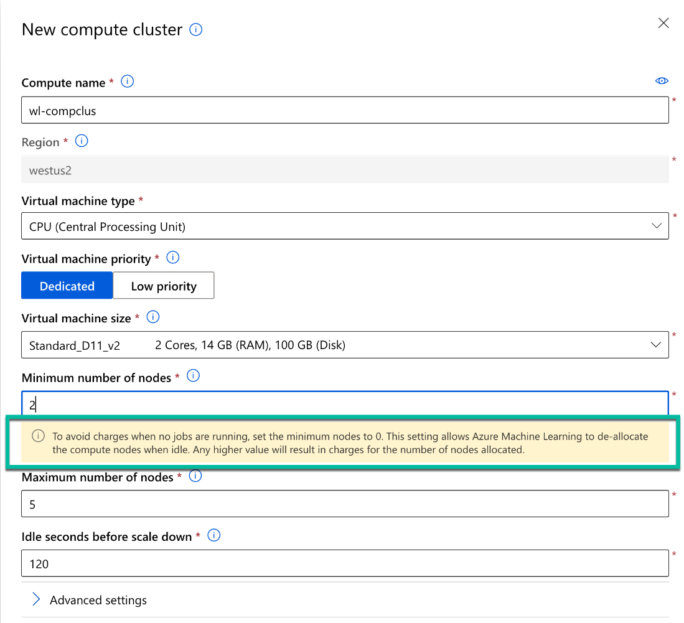

All other options are incorrect.

For more information about Azure ML Compute, please visit the below URLs-

* <https://docs.microsoft.com/en-us/learn/modules/create-classification-model-azure-machine-learning-designer/create-compute>

### **Question 26**

Unattempted

Domain :Describe features of computer vision workloads on Azure

Application scans image and immediately returns the following information- regions, lines for each region, and words for each line of text.

What Computer vision API does the application use for image scan?

]A.

**Read**

]B.

**NLP**

]C.

**OCR**

]D.

**Text Analytics**

]E.

**LUIS**

**Explanation:**

**Correct Answer: C**

OCR API is the part of Computer Vision services that extract small amounts of text within an image. It is a synchronous service specially designed to provide an immediate result.

It returns the following information.

* **Regions** on the image with text defined by bounding box coordinates
* **Lines** of text in each region also with bounding box coordinates
* **Words** in each line with bounding box coordinates
* **Option A is incorrect**since Read API helps to "read" texts within the images of predominantly documents. It is an asynchronous service specially designed for the heavy on text documents with many distortions.

All other options are incorrect because they are not dealing with extracting text from the images.

For more information about OCR API, please visit the below URLs-

* <https://docs.microsoft.com/en-us/learn/modules/read-text-computer-vision/2-ocr-azure>

### **Question 27**

Unattempted

Domain :Describe features of computer vision workloads on Azure

Please select all face emotion attributes that Azure Cognitive Face service provides information for.

A.

**hate**

B.

**fear**

C.

**smile**

D.

**contempt**

E.

**sparkle**

F.

**surprise**

G.

**neutral**

**Explanation:**

**Correct Answers: B, D, F, and G.**

Azure Cognitive Face service currently includes the following functionality.

Face detection, Face verification, Find similar faces, Group faces on similarities, and Person identification.

Azure Face API provides eight face emotion attributes with a confidence level. For example, below is the snapshot of JSON return from API call for the image with the face that reflects surprise and happiness.

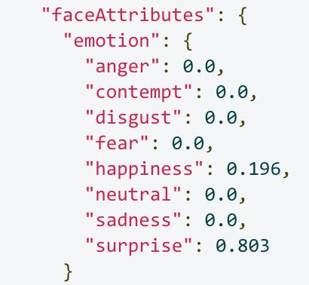

All other options are incorrect.

For more information about Face service, please visit the below URL-

* <https://docs.microsoft.com/en-us/azure/cognitive-services/face/concepts/face-detection>

### **Question 28**

Unattempted

Domain :Describe features of computer vision workloads on Azure

What are the three metrics that help to evaluate Custom vision model performance?

A.

**Accuracy**

B.

**Number of Points**

C.

**Precision**

D.

**Recall**

E.

**Mean Absolute Error (MAE)**

F.

**Average Precision (AP)**

**Explanation:**

**Correct Answers: C, D and F.**

Custom vision is one of the Computer Vision tasks. Custom vision service helps create your own computer vision model. There are three main performance metrics for the Custom vision models- Precision, Recall, and Average Precision (AP).

**Precision** defines the percentage of the class *predictions* that the model makes correct. For example, if the model predicts that ten images are bananas, and there are actually only seven bananas, the model precision is 70%.

**Recal**l defines the percentage of the class *identification* that the model makes correct. For example, if there are ten apple images, and the model identifies only eight, the model recall is 80%.

**Average Precision (AP)** is the combined metrics of both Precision and Recall.

* **Option A is incorrect**. Accuracy is a Classification model metric, but it is not used for Custom vision models performance assessments.
* **Option B is incorrect**. Number of Points is a Clustering model metric and is not used for Custom vision models performance assessments.
* **Option E is incorrect**. Mean Absolute Error (MAE) is a Regression model metric and is not used for Custom vision models performance assessments.

For more information about Custom vision, please visit the below URL-

* <https://docs.microsoft.com/en-us/learn/modules/classify-images-custom-vision/2-azure-image-classification>

### **Question 29**

Unattempted

Domain :Describe features of computer vision workloads on Azure

What are two automated document processing models Form Recognizer supports?

A.

**Standard cognitive model**

B.

**Custom model**

C.

**Auto OCR model**

D.

**A pre-build receipt model**

E.

**Custom vision**

**Explanation:**

**Correct Answers: B and D.**

Form Recognizer service is one of the Azure Computer vision solutions additional to Computer Vision service, Custom Vision Service and Face service.

For automated document processing, Form Recognizer uses two models- **Custom Model** and **A pre-build receipt model**.

With the **Custom model** approach, you train the Form Recognizer model based on your own form and data. You just need only 5 samples of your form to start.

**A pre-build receipt model** is a Form Recognizer default model that is trained to work with receipts. It helps recognize receipts and extract data from them.

All other options are incorrect.

For more information about Custom vision, please visit the below URL-

* <https://docs.microsoft.com/en-us/learn/modules/analyze-receipts-form-recognizer/2-receipts-azure>

### **Question 30**

Unattempted

Domain :Describe features of Natural Language Processing (NLP) workloads on Azure

What markup language will you use for the control of Speech Synthesis output for your phone auto attendant?

]A.

**HTML**

]B.

**SQL**

]C.

**SSML**

]D.

**JSON**

]E.

**TeX**

**Explanation:**

**Correct Answer: C**

Azure Cognitive services use Speech Synthesis Markup Language (SSML) for control of Speech Synthesis output. Using SSML and XML-based language, you can change the voice speed and pitch and regulate how the text or the text’s parts should be read.

* **Options B is incorrect** because SQL (Structured Query Language) is a data management language, not a markup language.
* **Options D is incorrect** because JSON (JavaScript Object Notation) is a data-interchange format, and it is not a markup language.
* **Option A and E are incorrect**. Even HTML (Hypertext Markup Language) and TeX are markup languages, but the Azure Cognitive services use SSML for the control of Speech Synthesis output.

For more information about SSML, please visit the below URL-

* <https://docs.microsoft.com/en-us/azure/cognitive-services/speech-service/speech-synthesis-markup?tabs=csharp>.

### **Question 31**

Unattempted

Domain :Describe features of Natural Language Processing (NLP) workloads on Azure

Please select two Translator Text API options that you can use for fine-tuning the results.

A.

**Speech Translation**

B.

**Selective Translation**

C.

**Text-to-speech**

D.

**Profanity filtering**

E.

**Semantic Translation**

**Explanation:**

**Correct Answers: B and D**

Azure Translator service supports multilanguage translations to and from 70 languages.

Translator Text API service has two options that can help users fine-tune their results- **Profanity filtering** and **Selective Translation**.

* **Profanity** **filtering** option helps control a translation of the profanity words by marking them as profanity or just by omitting them from the result.
* **Selective Translation** option allows you to specify by tagging a word or phrases that you don't want to translate, like a brand name.
* **Option A is incorrect** because Speech Translation is a separate audio translation service and is not an option of Translator Text service.
* **Option C is incorrect** because Text-to-speech is a part of Speech Translation that generates audio from the text source and is not an option of Translator Text service.
* **Option D is incorrect** because Semantic Translation is a translation technique that Azure Translator utilizes for a more precise output that reflects the source's semantic content. It is not an option of Translator Text service.

For more information about Azure Text Translator, please visit the below URLs-

* <https://docs.microsoft.com/en-us/learn/modules/translate-text-with-translation-service/2-get-started-azure>

### **Question 32**

Unattempted

Domain :Describe features of Natural Language Processing (NLP) workloads on Azure

You need to create a Language Understanding Web App Bot.  You decided to use the Basic Bot template.

Does this decision help you achieve your goal?

]A.**Yes**

]B.**No**

**Explanation:**

**Correct Answer: A**

Out of the box, Azure portal provides two main templates for creating bots- **Echo Bot** and **Basic bot**.

* **Echo Bot** is a template for a simple application that echoes the user's messages.
* **Basic Bot** is a template for bot application that provides Language understanding and Bot Analytics support.

If you need to create a bot with Language understanding, you should select the Basic Bot template in the Azure Web Bot panel. After that, you will see new options for the new or existent LUIS App Location and account.

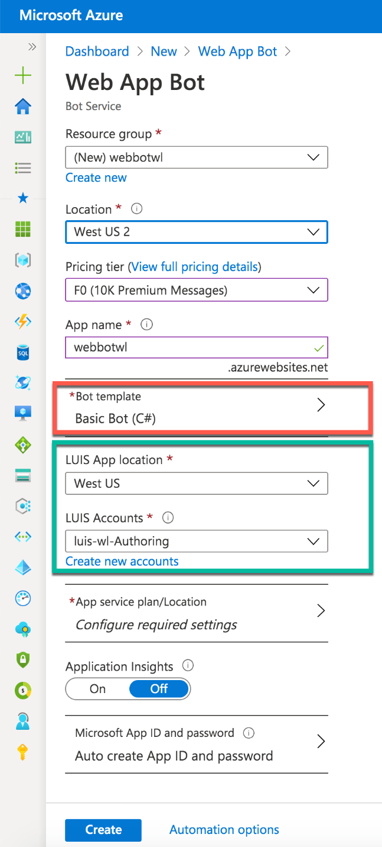

For more information about LUIS and Language understanding bot, please visit the below URLs-

* <https://docs.microsoft.com/en-us/azure/bot-service/abs-quickstart?view=azure-bot-service-4.0>
* <https://docs.microsoft.com/en-us/learn/modules/create-language-model-with-language-understanding/2-get-started>

### **Question 33**

Unattempted

Domain :Describe features of Natural Language Processing (NLP) workloads on Azure

What are the two default scenarios for Azure Speech-to-Text service?

A.

**Conversational**

B.

**Recognition**

C.

**Dictation**

D.

**Acoustics**

E.

**Pronunciation**

**Explanation:**

**Correct Answers: A and C**

By default, Azure Speech-to-Text Service uses the Universal language model - Microsoft's proprietary model optimized for conversational and dictation scenarios.

All other options are Speech-to-Text settings that users can optimize individually for their applications.

For more information about Azure Speech-to-Text service, please visit the below URLs-

* <https://docs.microsoft.com/en-us/learn/modules/recognize-synthesize-speech/2-get-started-azure>
* <https://docs.microsoft.com/en-us/azure/cognitive-services/speech-service/speech-to-text>

### **Question 34**

Unattempted

Domain :Describe features of conversational AI workloads on Azure

You want to add Web Chat control to your website. You created a bot using Azure Bot Service.

What are two steps you need to do before adding a bot control to your production web site?

A.

**Create a Knowledge base**

B.

**Obtain bot's secret**

C.

**Create a QnA application**

D.

**Generate token**

E.

**Add additional channels**

**Explanation:**

**Correct Answers: B and D.**

After you created a bot using Azure Portal, Bot Framework generates Web Chat control by default. You can embed this control within the website's code. This control requires a secret key for bot access. You can find a secret key and code for embedding the bot's control into the website under the Channels panel.

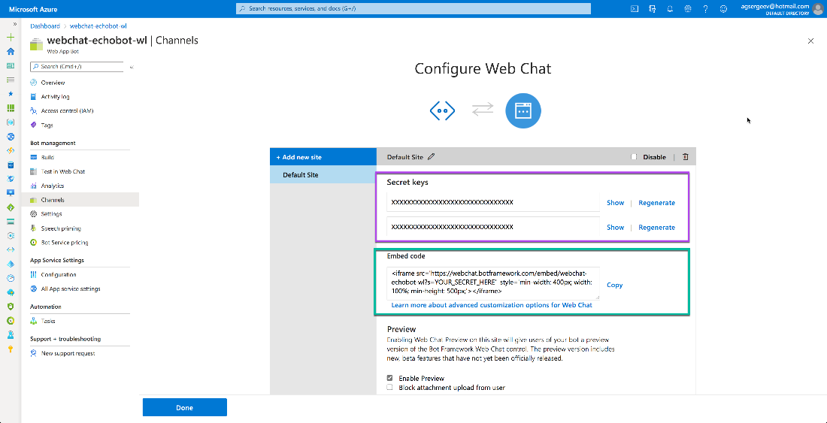

The secret key is a master key that allows you access to all bot's conversations. Its free exposure creates a significant security risk. To limit this risk in a production environment, you need to generate a token based on the secret key. A token gives you access only to a single conversation and has an expiration term.

All other options are incorrect.

For more information about the Bot Service connection, please visit the below URL-

* <https://docs.microsoft.com/en-us/azure/bot-service/bot-service-channel-connect-webchat?view=azure-bot-service-4.0#get-your-bot-secret-key>.

### **Question 35**

Unattempted

Domain :Describe features of Natural Language Processing (NLP) workloads on Azure

You need to create a Web Bot using the Azure portal. You have to choose a bot template.

What are two SDK languages you can select for the bot template?

A.

**C++**

B.

**Node.js**

C.

**Python**

D.

**C#**

E.

**Java**

**Explanation:**

**Correct Answers: B and D**

Azure Bot Framework SDK provides templates only for two languages: C# and Node.js.

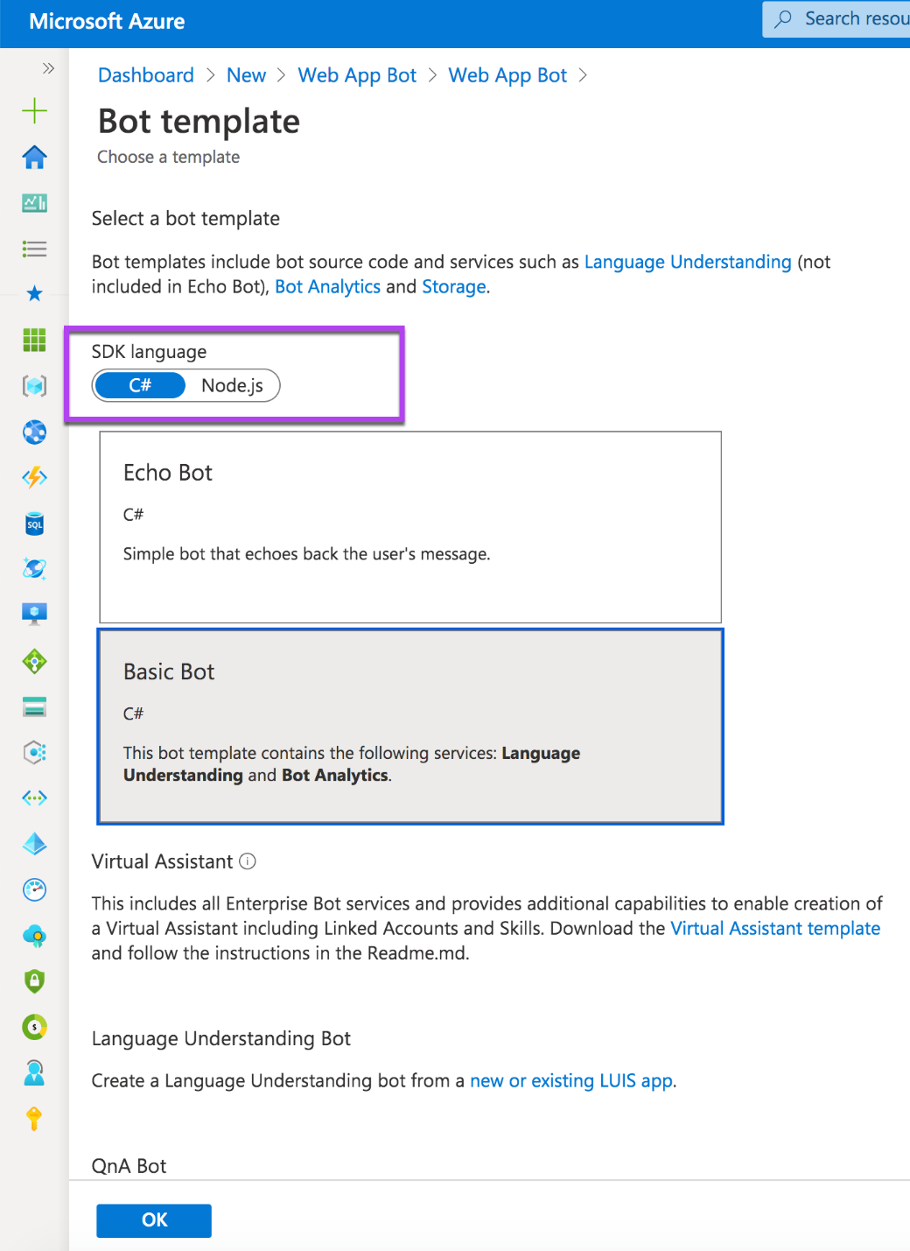

All other options are incorrect.

For more information about Bot Framework Templates, please visit the below URL-

* <https://docs.microsoft.com/en-us/azure/bot-service/abs-quickstart?view=azure-bot-service-4.0>.

### **Question 36**

Unattempted

Domain :Describe AI workloads and considerations

What Machine Learning feature does help people without any data science experience to create an Azure ML model from data?

]A.

**Azure Machine Learning designer**

]B.

**Pipelines**

]C.

**Automated machine learning**

]D.

**Object Detection**

]E.

**Anomaly Detection**

]F.

**Text Analytics**

]G.

**Data and compute management**

**Explanation:**

**Correct Answer: C**

Microsoft Machine Learning is the foundation for Artificial Intelligence service. It includes four features and capabilities.

* **Automated machine learning**—automated creation of ML models based on your data; doesn’t require any data science experience.
* **Azure Machine Learning designer**—a graphical interface for no-code creation of the ML solutions
* **Data and Compute managemen**t—cloud-based tools for data science professionals,
* **Pipelines**—visual designer for creating ML tasks workflow

* **Option E is incorrect.**Anomaly Detection—is one of the key elements of Artificial Intelligence, and it is not a feature of Machine Learning.
* **Option D is incorrect.** Object Detection—is one of the common tasks of Computer Vision and is not part of Machine Learning.
* **Option G is incorrect.** Text Analytics—is a feature of Natural language processing and is not a part of Machine Learning.

All other options are incorrect.

For more information about the features and capabilities of Machine Learning, please visit the below URL-

* <https://docs.microsoft.com/en-us/learn/modules/get-started-ai-fundamentals/2-understand-machine-learn>

### **Question 37**

Unattempted

Domain :Describe AI workloads and considerations

What is the name of the Natural Language Processing service that enables language interaction between users and Conversational AI agents?

]A.

**Text Analytics**

]B.

**QnA Maker**

]C.

**LUIS**

]D.

**Azure Bot Service**

]E.

**Translator Text**

]F.

**Automated machine learning**

**Explanation:**

**Correct Answer: C**

Natural Language Processing (NLP) is one of the key elements for Artificial Intelligence. It includes four services.

* **Text Analytics**helps analyze text documents, detect the document’s language, extract key phrases, determine entities, and provide sentiment analysis.
* **Translator Text**helps translate texts between 60+ languages.
* **Speech**helps recognize and synthesize speech, recognize and identify speakers, translate live or recorded speech.
* **Language Understanding Intelligent Service (LUIS)**helps understand voice or text commands.

* **Option B is incorrect.** QnA Maker is a part of Conversation AI services. It helps create a knowledge base that serves as a foundation for a conversation between humans and AI agents. But we need to use LUIS as a provider of such conversations.
* **Option D is incorrect.**Azure Bot Service is a part of Conversation AI services. It helps to create, publish, and manage Conversation AI agents. But we need to use LUIS that enables language interaction between users and Conversational AI agents.
* **Option F is incorrect.**Automated machine learning is a part of Machine Learning that provides automated creation of ML models based on your data. It is not an NLP service.

All other options are incorrect.

For more information about Natural Language Processing services, please visit the below URLs-

* <https://docs.microsoft.com/en-us/learn/modules/get-started-ai-fundamentals/5-understand-natural-language-process>
* <https://docs.microsoft.com/en-us/azure/cognitive-services/luis/what-is-luis>

### **Question 38**

Unattempted

Domain :Describe AI workloads and considerations

You created an AI solution that screens and selects applicants for the jobs. Your AI solution treats all applicants only based on their professional qualifications.

What responsible AI guiding principle does your solution follow?

]A.

**Transparency**

]B.

**Reliability and safety**

]C.

**Fairness**

]D.

**Inclusiveness**

]E.

**Privacy and security**

]F.

**Accountability**

**Explanation:**

**Correct Answer: C**

Microsoft recognizes six principles of responsible AI.

Fairness, Reliability, and safety, Privacy and security, Transparency, Inclusiveness and Accountability.

The principle of Fairness directs AI solutions to treat everybody equitably — independent of gender, race, or any bias. Your AI solution must treat all applications in the same way based on the professional qualifications of the applicants. We need to be sure that AI solutions don’t include any bias.

All other options are incorrect.

For more information about guiding principles for responsible AI, please visit the below URLs-

* <https://www.microsoft.com/en-us/ai/responsible-ai?activetab=pivot1:primaryr6>
* <https://docs.microsoft.com/en-us/learn/modules/responsible-ai-principles/4-guiding-principles>

### **Question 39**

Unattempted

Domain :Describe AI workloads and considerations

You need to meet the defined legal and ethical standards in your AI solution.

Does it mean that you follow the Transparency guiding principle of responsible AI?

]A.**Yes**

]B.**No**

**Explanation:**

**Correct Answer: B**

Microsoft recognizes six principles of responsible AI.

Fairness, Reliability, and safety, Privacy and security, Transparency, Inclusiveness and Accountability.

The principle of Accountability directs AI solutions to follow governance and organizational norms as they are defined by legal and ethical standards.

All other options are incorrect.

For more information about guiding principles for responsible AI, please visit the below URLs-

* <https://www.microsoft.com/en-us/ai/responsible-ai?activetab=pivot1:primaryr6>
* <https://docs.microsoft.com/en-us/learn/modules/responsible-ai-principles/4-guiding-principles>

### **Question 40**

Unattempted

Domain :Describe fundamental principles of machine learning on Azure

Your company created a new mobile phone. You need to define a price range (0 - low cost to 3 - very high cost) for the phone. You collected technical and sales data for the phones on the market. Now you are ready to train your model. Here is your train dataset.

|  |  |  |  |  |  |
| --- | --- | --- | --- | --- | --- |
| Battery power | Clock speed | Dual sim | Color | Internal memory | Price range |
| 842 | 2.2 | 0 | black | 7 | 1 |
| 1021 | 0.5 | 1 | black | 53 | 2 |
| 563 | 0.5 | 1 | black | 41 | 2 |
| 615 | 2.5 | 0 | black | 10 | 2 |
| 1821 | 1.2 | 0 | black | 44 | 1 |
| 1859 | 0.5 | 1 | black | 22 | 1 |
| 1821 | 1.7 | 0 | black | 10 | 3 |
| 1954 | 0.5 | 1 | black | 24 | 0 |
| 1445 | 0.5 | 0 | black | 53 | 0 |
| 509 | 0.6 | 1 | black | 9 | 0 |

What type of model will you train?

]A.

**Regression model**

]B.

**Classification model**

]C.

**Clustering model**

]D.

**Unsupervised model**

**Explanation:**

**Correct Answer: B**

We are training the Classification model. In our case, we are using the historical data and predicting the price range category that a new phone belongs to.

The “Price range” column is our target or label, and it has four classes: 0 (low cost), 1(medium cost), 2(high cost), and 3(very high cost). The model output value will be one of these four classes.

* **Option A is incorrect.** Even the Regression model uses historical data for model training. But it predicts the output numeric value, not the class or classes.
* **Option C is incorrect.** Clustering model cluster unlabeled data into groups based on some common properties.
* **Option D is incorrect**. An unsupervised model uses unlabeled data.

For more information about Machine Learning model types, please visit the below URLs-

* <https://docs.microsoft.com/en-us/learn/modules/create-classification-model-azure-machine-learning-designer/introduction>
* <https://docs.microsoft.com/en-us/learn/modules/create-regression-model-azure-machine-learning-designer/>
* <https://docs.microsoft.com/en-us/learn/modules/create-clustering-model-azure-machine-learning-designer/>

### **Question 41**

Unattempted

Domain :Describe fundamental principles of machine learning on Azure

You train the ML model with an unlabeled dataset.

What type of model are you creating?

Select all that apply.

A.

**Classification model**

B.

**Unsupervised ML model**

C.

**Supervised ML model**

D.

**Clustering model**

E.

**Regression model**

**Explanation:**

**Correct Answers: B and D.**

Usually, if you are using unlabeled data, you are creating an Unsupervised ML model. The most common use of the Unsupervised ML is to cluster unlabeled data into groups based on some common properties.

Regression and Classification modeling types are two parts of Supervised machine learning that use labeled data for model training.

* **Option A is incorrect**because the Classification model uses labeled datasets for model training.
* **Option E is incorrect**because the Regression model uses labeled datasets for model training.
* **Option C is incorrect** because Supervised ML includes modeling with labeled datasets.

For more information about Clustering models, please visit the URL-

* <https://docs.microsoft.com/en-us/learn/modules/create-clustering-model-azure-machine-learning-designer/create-training-pipeline>.

### **Question 42**

Unattempted

Domain :Describe fundamental principles of machine learning on Azure

Your company created a new mobile phone. You need to define a price range (0 - low cost to 3 - very high cost) for the phone. You collected technical and sales data for the phones on the market and ready to train your model. Here is your train dataset.

|  |  |  |  |  |  |
| --- | --- | --- | --- | --- | --- |
| Battery power | Clock speed | Dual sim | Color | Internal memory | Price range |
| 842 | 2.2 | 0 | black | 7 | 1 |
| 1021 | 0.5 | 1 | black | 53 | 2 |
| 563 | 0.5 | 1 | black | 41 | 2 |
| 615 | 2.5 | 0 | black | 10 | 2 |
| 1821 | 1.2 | 0 | black | 44 | 1 |
| 1859 | 0.5 | 1 | black | 22 | 1 |
| 1821 | 1.7 | 0 | black | 10 | 3 |
| 1954 | 0.5 | 1 | black | 24 | 0 |
| 1445 | 0.5 | 0 | black | 53 | 0 |
| 509 | 0.6 | 1 | black | 9 | 0 |

What will be the label for this model?

]A.

**Battery power**

]B.

**Clock speed**

]C.

**Dual sim**

]D.

**Color**

]E.

**Internal memory**

]F.

**Price Range**

**Explanation:**

**Correct Answer: F**

The **label** is a generic name for the model output value or class. In our case, we are predicting the price range category that a new phone belongs to. The “Price range” column is our label.

All other options are incorrect because these columns are inputs or **features** for the model.

For more information about features and labels, please visit the below URLs-

* <https://docs.microsoft.com/en-us/learn/modules/use-automated-machine-learning/what-is-ml>
* <https://docs.microsoft.com/en-us/learn/modules/create-classification-model-azure-machine-learning-designer/>

### **Question 43**

Unattempted

Domain :Describe fundamental principles of machine learning on Azure

You are using Two-class logistic regression algorithm to train your model.

What type of model are you creating?

]A.

**Regression Model**

]B.

**Classification Model**

]C.

**Clustering Model**

]D.

**Unsupervised Modeling**

**Explanation:**

**Correct Answer: B**

All algorithms in the ML Classification family include the word "class" in their names, such as

Two-**class** logistic regression, Multi**class** logistic regression, or Multi**class** forest regression.

If you are using a Two-class logistic regression algorithm, you are training the Classification model.

All other options are incorrect.

For more information about Azure ML algorithms, please visit the below URL-

* <https://docs.microsoft.com/en-us/azure/machine-learning/how-to-select-algorithms>

### **Question 44**

Unattempted

Domain :Describe fundamental principles of machine learning on Azure

You created a classification model. Below is the confusion matrix for this model.



Please select the formula for model Accuracy calculation.

]A.

**TP/(TP+FN)**

]B.

**(TP+TN)/Total number of cases**

]C.

**TP/(TP+FP)**

]D.

**2TP/(2TP+FP+FN)**

]E.

**TN/(TN+FP)**

**Explanation:**

**Correct Answer: B**

The confusion matrix (or error matrix) provides a tabulated view of predicted and actual values for each class. It is usually used as a performance assessment for classification models.

A binary confusion matrix is divided into four squares that represent the following values.

* True positive (TP) — the number of positive cases that the model predicted right.
* True negative (TN) — the number of negative cases that the model predicted right.
* False positive (FP) — the number of positive cases that the model falsely predicted right.
* False negative (FN) — the number of negative cases that the model falsely predicted right.



**Accuracy** metric defines how many predictions (positive and negative) are actually predicted right. We can calculate this metric using the following formula: (TP+TN)/Total number of cases.

* **Option A is incorrect.** This expression is for Recall metric calculation: TP/(TP+FN).
* **Option C is incorrect.**This expression is for Precision metric calculation: TP/(TP+FP).
* **Option D is incorrect.**This expression is for F1 Score metric calculation: 2TP/(2TP+FP+FN).
* **Option E is incorrect.**This expression is for Selectivity (or true negative rate) metric calculation: TN/(TN+FP).

For more information about the Confusion matrix, please visit the URLs below-

* <https://docs.microsoft.com/en-us/learn/modules/create-classification-model-azure-machine-learning-designer/evaluate-model>
* <https://docs.microsoft.com/en-us/azure/machine-learning/how-to-understand-automated-ml#confusion-matrix>.

### **Question 45**

Unattempted

Domain :Describe fundamental principles of machine learning on Azure

Your company created a new mobile phone. You need to define a price range (0 - low cost to 3 - very high cost) for the phone. You collected technical and sales data for the phones on the market and ready to train your model. Here is your train dataset.

|  |  |  |  |  |  |
| --- | --- | --- | --- | --- | --- |
| Battery power | Clock speed | Dual sim | Color | Internal memory | Price range |
| 842 | 2.2 | 0 | black | 7 | 1 |
| 1021 | 0.5 | 1 | black | 53 | 2 |
| 563 | 0.5 | 1 | black | 41 | 2 |
| 615 | 2.5 | 0 | black | 10 | 2 |
| 1821 | 1.2 | 0 | black | 44 | 1 |
| 1859 | 0.5 | 1 | black | 22 | 1 |
| 1821 | 1.7 | 0 | black | 10 | 3 |
| 1954 | 0.5 | 1 | black | 24 | 0 |
| 1445 | 0.5 | 0 | black | 53 | 0 |
| 509 | 0.6 | 1 | black | 9 | 0 |

What column will you discard from the final dataset during feature selection?

]A.

**Battery power**

]B.

**Clock speed**

]C.

**Dual sim**

]D.

**Color**

]E.

**Internal memory**

]F.

**Price Range**

**Explanation:**

**Correct Answer: D**

Data pre-processing involves various techniques, like feature selection, normalization or feature engineering, etc.

During feature selection, we identify features that would help us with label prediction. And we discard the rest. In our dataset, the Color feature wouldn't correlate with the label due to the constant value of "black.” We can safely remove this feature from the final dataset.

All other options should be included in the training dataset.

For more information about Feature selection, please visit the URL-

* <https://docs.microsoft.com/en-us/learn/modules/use-automated-machine-learning/what-is-ml>

### **Question 46**

Unattempted

Domain :Describe fundamental principles of machine learning on Azure

Your company created a new mobile phone. You need to define a price range (0 - low cost to 3 - very high cost) for the phone. You collected technical and sales data for the phones on the market and ready to train your model. Here is your train dataset.

|  |  |  |  |  |  |
| --- | --- | --- | --- | --- | --- |
| Battery power | Clock speed | Dual sim | Color | Internal memory | Price range |
| 842 | 2.2 | 0 | black | 7 | 1 |
| 1021 | 0.5 | 1 | black | 53 | 2 |
| 563 | 0.5 | 1 | black | 41 | 2 |
| 615 | 2.5 | 0 | black | 10 | 2 |
| 1821 | 1.2 | 0 | black | 44 | 1 |
| 1859 | 0.5 | 1 | black | 22 | 1 |
| 1821 | 1.7 | 0 | black | 10 | 3 |
| 1954 | 0.5 | 1 | black | 24 | 0 |
| 1445 | 0.5 | 0 | black | 53 | 0 |
| 509 | 0.6 | 1 | black | 9 | 0 |

What data transformation modules will you use in Azure ML Designer before submitting your dataset for the training?

Please select all that apply.

A.

**Select Columns in Dataset**

B.

**Partition and Sample**

C.

**Normalize Data**

D.

**Apply Math Operation**

E.

**Split Data**

**Explanation:**

**Correct Answers: A, C, and E**

Data pre-processing involves various techniques, like feature selection, normalization or feature engineering, etc.

We need to use the “Select Columns in Dataset” module for feature selection for our dataset. Then we will use the “Normalize Data” module for bringing all numeric data to a common scale. And after that, we can use the "Split data" for training and testing sets.

You can find all these three modules under the “Data transformation” group on Azure ML Designer Assets Panel.

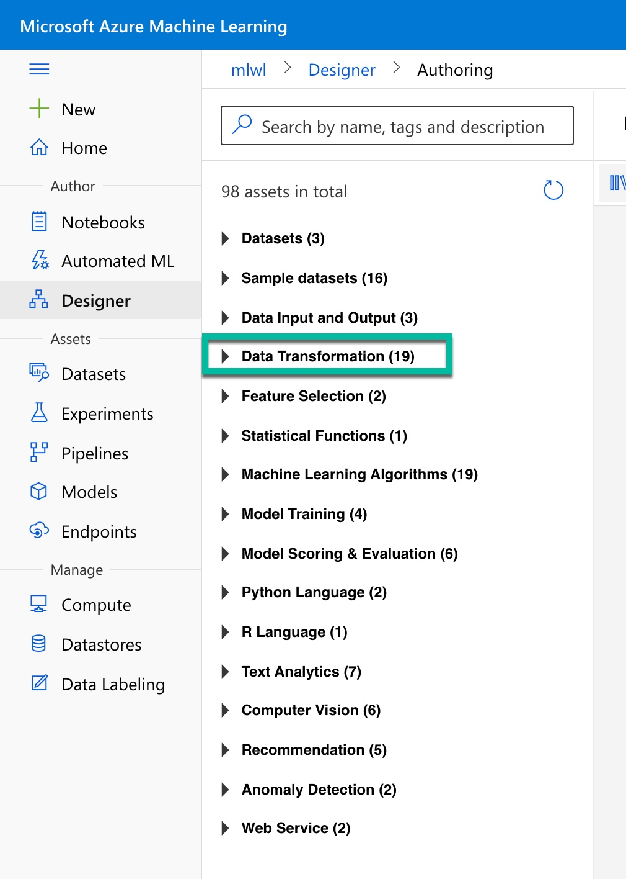

All other options are incorrect.

For more information about Data pre-processing, please visit the below URLs-

* <https://docs.microsoft.com/en-us/learn/modules/create-classification-model-azure-machine-learning-designer/evaluate-model>
* <https://docs.microsoft.com/en-us/learn/modules/use-automated-machine-learning/what-is-ml>

### **Question 47**

Unattempted

Domain :Describe fundamental principles of machine learning on Azure

What metrics does Azure ML use for the evaluation of the Clustering models?

Select all that apply.

A.

**Root Mean Squared Error (RMSE)**

B.

**Number of Points**

C.

**Accuracy**

D.

**Combined Evaluation**

E.

**Precision**

F.

**Coefficient of Determination**

G.

**Average Distance to Cluster Center**

**Explanation:**

**Correct Answers: B, D and G**

Azure ML uses model evaluation for the measurement of the trained model accuracy.

For Clustering models, the Evaluate Model module provides the following five metrics-   
Average Distance to Other Center, Average Distance to Cluster Center, Number of Points, Maximal Distance to Cluster Center, Combined Evaluation.

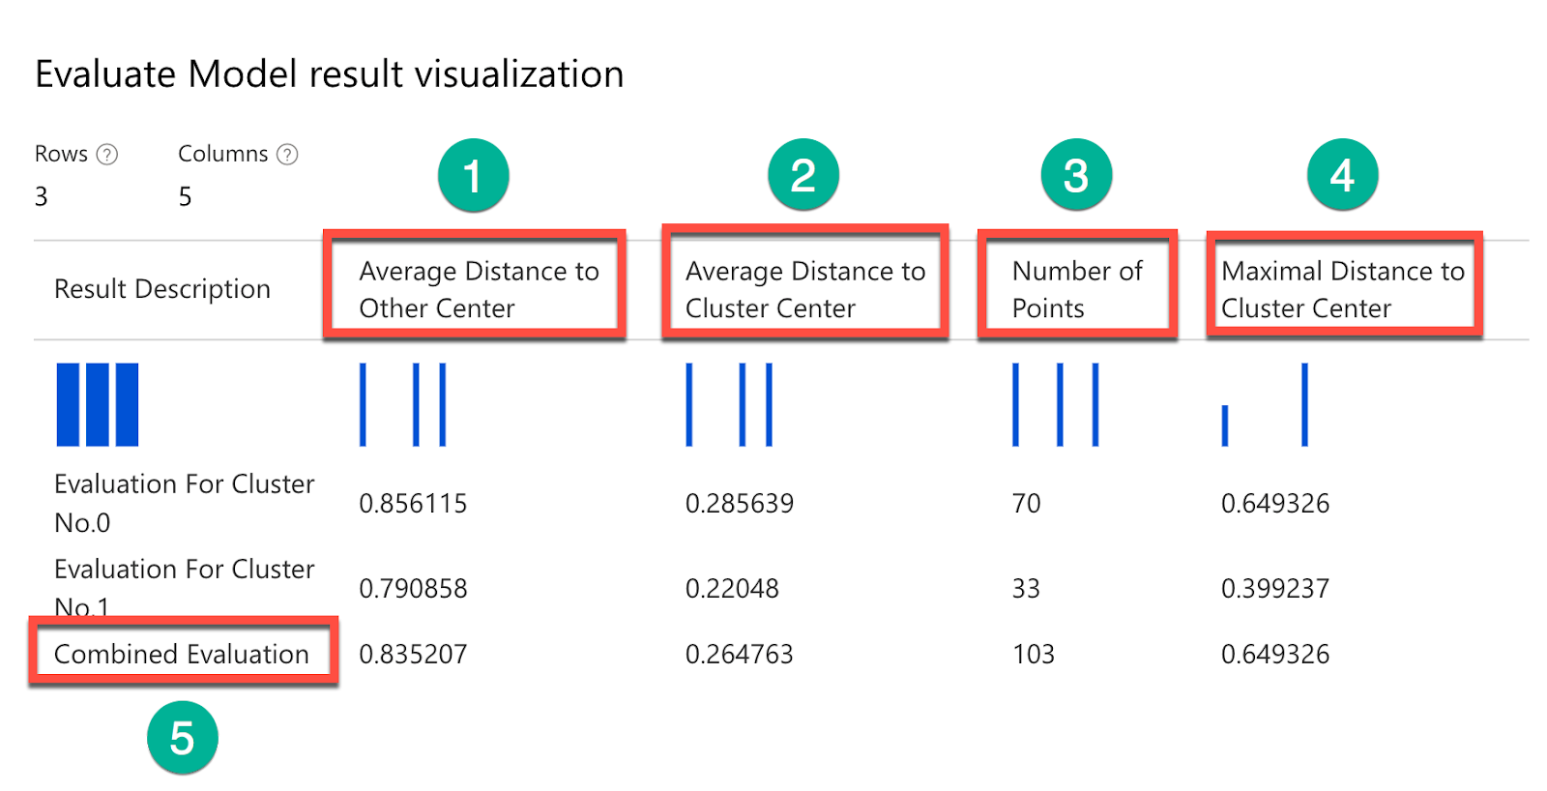

* **Option B is correct.**Number of Points is the clustering model evaluation metrics. It represents how many data points are assigned to the cluster.
* **Option D is correct.** Combined Evaluation is the clustering model evaluation metrics. It represents an average score for the model clusters.
* **Option G is correct.**Average Distance to Cluster Center is the clustering model evaluation metrics. It represents the average distance from the center of the cluster to each data point.
* **Option A is incorrect.** Root Mean Squared Error (RMSE) is the regression model evaluation metrics.  It represents the square root from the squared mean of the errors between predicted and actual values. It is not the clustering model evaluation metrics.
* **Option C is incorrect.** Accuracy is the classification model evaluation metrics. It represents how many cases the model predicted right proportionally to the total number of cases. It is not the clustering model evaluation metrics.
* **Option E is incorrect.** Precision is the classification model evaluation metrics. It represents how many positive cases are predicted right. It is not the clustering model evaluation metrics.
* **Option F is incorrect.** Coefficient of determination or R2 is the regression model evaluation metrics. It is not the clustering model evaluation metrics.

For more information about Azure ML evaluation of the clustering models, please visit the below URLs-

* <https://docs.microsoft.com/en-us/learn/modules/create-clustering-model-azure-machine-learning-designer/evaluate-model>
* <https://docs.microsoft.com/en-us/azure/machine-learning/algorithm-module-reference/evaluate-model>

### **Question 48**

Unattempted

Domain :Describe fundamental principles of machine learning on Azure

You need to bring numeric features to the common scale in your dataset.

What Azure ML Designer module will you use for this purpose?

]A.

**Select Columns in Dataset**

]B.

**Clean Missing Data**

]C.

**Normalize Data**

]D.

**Split Data**

]E.

**Clip Values**

**Explanation:**

**Correct Answer:  C**

You need to normalize your numeric features. The process of normalization brings numeric features to a common scale.

Azure ML Designer provides the Normalize Data module for this purpose.

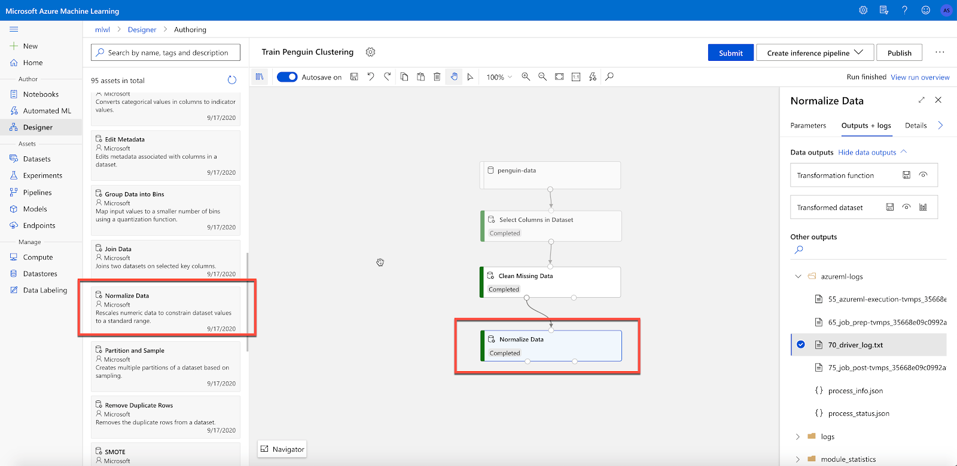

Data before the Normalize data module.

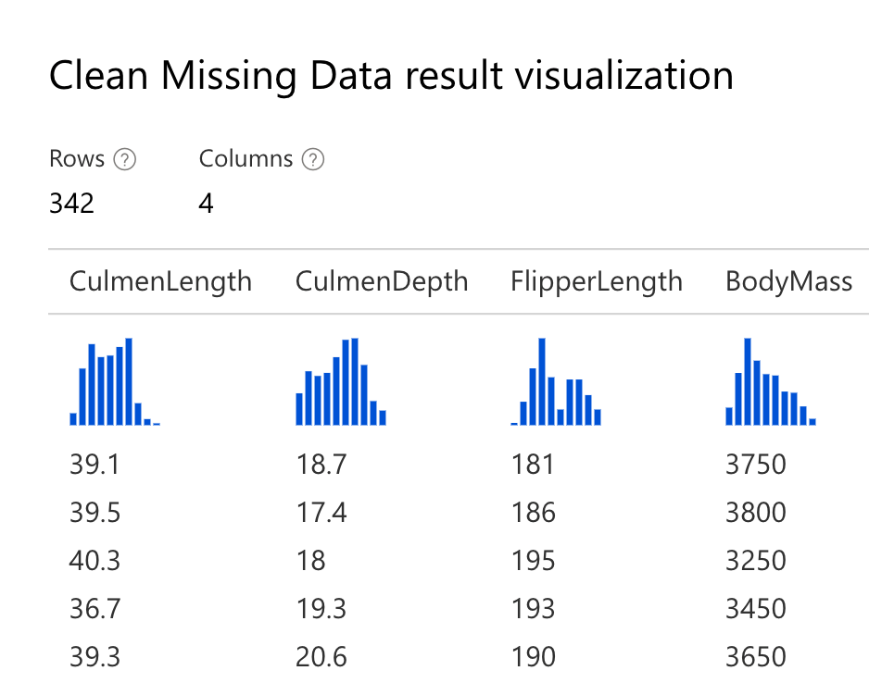

And data after Normalize Data module.

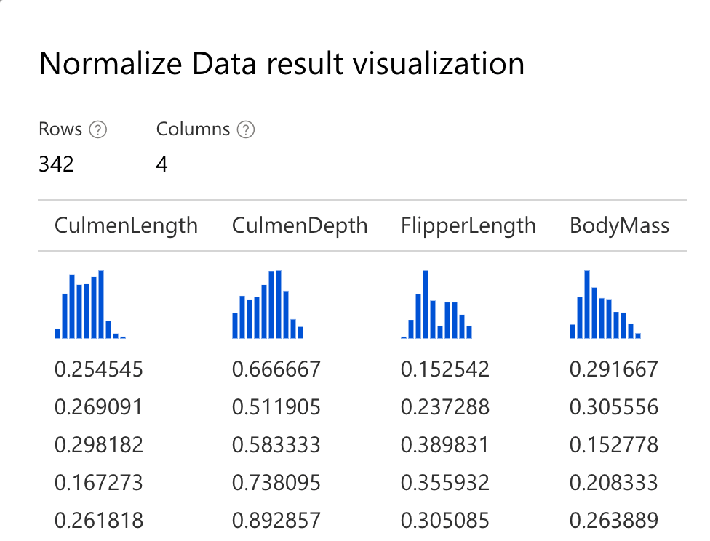

* **Option A is incorrect.**“Select Columns in Dataset” module helps select or exclude columns from the model training dataset.
* **Option B is incorrect.** “Clean Missing Data” module takes care of missing data in a dataset.
* **Option D is incorrect**. “Split Data” module divides data into training and testing datasets.
* **Option E is incorrect**. “Clip Values” module detects outliers and clips or replaces their values.

For more information about the Normalize data module, please visit the below URLs-

* <https://docs.microsoft.com/en-us/azure/machine-learning/algorithm-module-reference/normalize-data>

### **Question 49**

Unattempted

Domain :Describe features of computer vision workloads on Azure

Object detection model cannot detect objects less than …

]A.

**3% of the image**

]B.

**5% of the image**

]C.

**7% of the image**

]D.

**10% of the image**

]E.

**15% of the image**

**Explanation:**

**Correct Answer: B**

Object detection is one of the common tasks of Computer Vision. The Object detection model helps identify objects and their boundaries within the image. Unfortunately, there are several limitations to this service.

1. It can't detect the small objects (less than 5% of the image).
2. It can't detect objects that very close together, like a stack of plates.
3. It can't detect brands or product names. You can use Brand detection for this purpose.

All other options are incorrect.

For more information about Object detection, please visit the below URLs-

* <https://docs.microsoft.com/en-us/azure/cognitive-services/computer-vision/concept-object-detection>

### **Question 50**

Unattempted

Domain :Describe features of computer vision workloads on Azure

Can Face service see face makeup in the person’s face image?

]A.**Yes**

]B.**No**

**Explanation:**

**Correct Answer: A**

Azure Cognitive Face service currently includes the following functionality.

Face detection, Face verification, Find similar faces, Group faces on similarities, and Person identification.

Face API service call returns Face Attributes. Face attributes include age, gender, smile, glasses, emotion, makeup, hair, etc.

Here is an example of the JSON result for the makeup attribute.

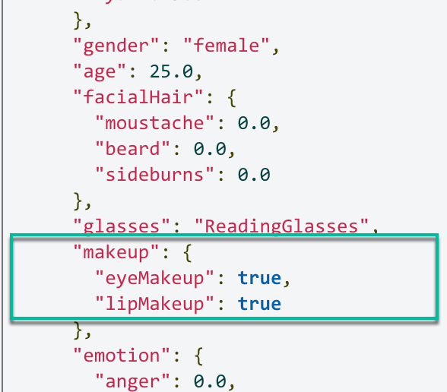

For more information about Azure Face services, please visit the below URL-

* <https://docs.microsoft.com/en-us/azure/cognitive-services/face/overview>.

### **Question 51**

Unattempted

Domain :Describe features of Natural Language Processing (NLP) workloads on Azure

You are using Text Analytics Key Phrases API to analyze the following sentence- "Peter met Sara at Microsoft headquarters in Paris.”

How many key phrase items should you expect in the API response?

]A.

**0**

]B.

**2**

]C.

**3**

]D.

**4**

]E.

**5**

**Explanation:**

**Correct Answer: D**

Key Phrase is a Text Analytics service that helps identify the main talking points of the document.

In our case, there are four main words/phrases: “Peter,” “Sara,” “Microsoft headquarters,” and “Paris.”

Here is the JSON result.

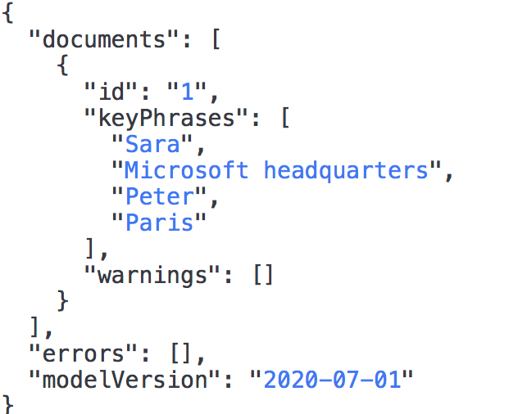

All other options are incorrect.

For more information about Key Phrases service, please visit the below URLs-

* <https://docs.microsoft.com/en-us/learn/modules/analyze-text-with-text-analytics-service/2-get-started-azure>

### **Question 52**

Unattempted

Domain :Describe features of Natural Language Processing (NLP) workloads on Azure

You are using Text Analytics Sentiment API to analyze the following sentence- "Peter was surprised and very happy to meet Sara in Paris.”

What a sentiment value should you expect in the API response?

]A.

**neutral**

]B.

**positive**

]C.

**happy**

]D.

**negative**

]E.

**surprise**

**Explanation:**

**Correct Answer: B**

Sentiment Analysis is a Text Analytics service that helps analyze text and returns sentiment scores (between 0 and 1) for each sentence.

A score close to 0 means a negative sentiment, and a score close to 1 means positive. And in cases with a neutral or undefined sentiment, the score is 0.5.

In our problem, the sentiment of the sentence is positive, with a confidence score of 1.0.

Here is the JSON result.

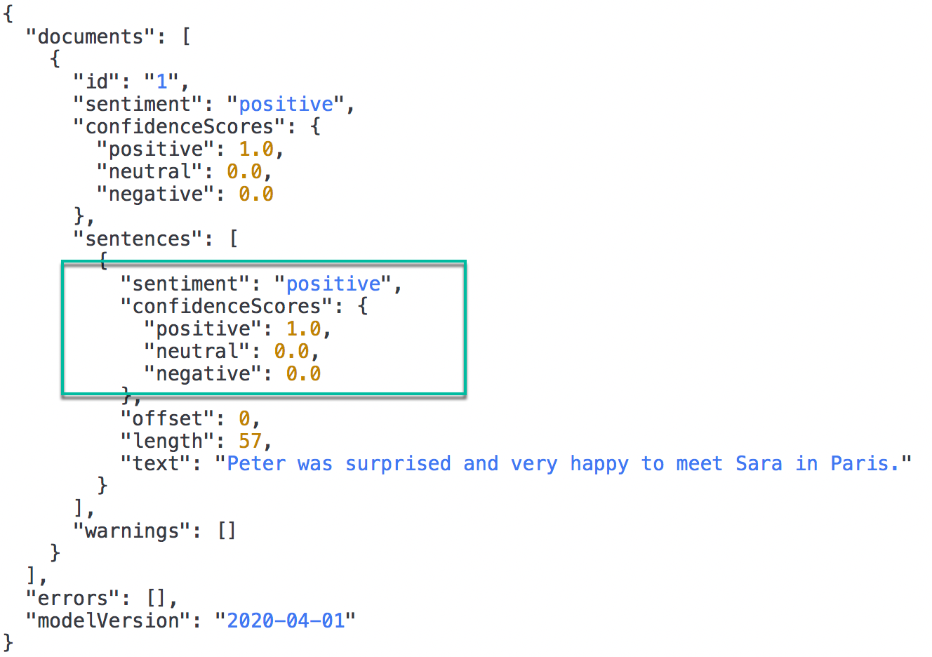

All other options are incorrect.

For more information about Sentiment Analysis, please visit the below URLs-

* <https://docs.microsoft.com/en-us/learn/modules/analyze-text-with-text-analytics-service/2-get-started-azure>
* <https://westus.dev.cognitive.microsoft.com/docs/services/TextAnalytics-v3-0/operations/Sentiment>

### **Question 53**

Unattempted

Domain :Describe features of Natural Language Processing (NLP) workloads on Azure

You need to translate a short document into several languages. You decided to use Translator API.

Can you submit a text for the translation to all required languages in one request?

]A.**Yes**

]B.**No**

**Explanation:**

**Correct Answer: A**

Azure Translator service supports multi-language translations to and from 70 languages. If you need to translate the same text into several languages, you can do it in one request to API. In an API request, you submit a text in the call’s body and a sequence of the language codes you need to translate to as parameters.

Here is an example of an API call-

* [https://api.cognitive.microsofttranslator.com/translate?api-version=3.0&**to=es**](https://api.cognitive.microsofttranslator.com/translate?api-version=3.0&to=es&to=de&to=zh-Hans&to=ru)[&**to=de**&**to=zh-Hans**&**to=ru**](https://api.cognitive.microsofttranslator.com/translate?api-version=3.0&to=es&to=de&to=zh-Hans&to=ru)

And here is the result of the call.

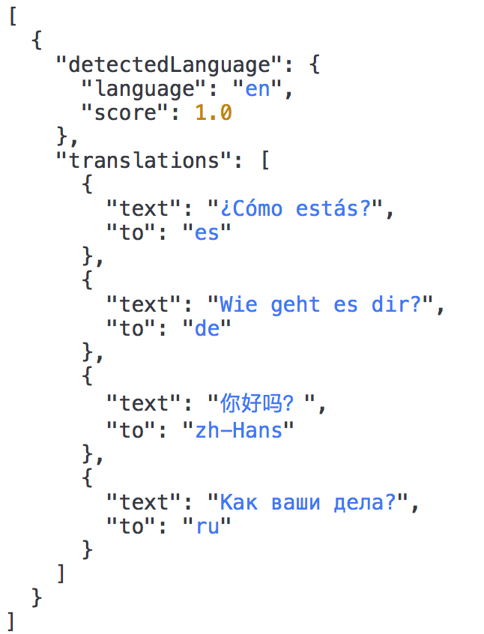

For more information about Translation to multiple languages, please visit the below URLs:

* <https://docs.microsoft.com/en-us/azure/cognitive-services/translator/reference/v3-0-translate#translate-to-multiple-languages>

### **Question 54**

Unattempted

Domain :Describe AI workloads and considerations

What is the main foundation for the Personal Digital Assistant?

]A.

**Azure Speech**

]B.

**Bot Framework**

]C.

**Computer Vision Service**

]D.

**Text Analytics**

]E.

**Automated Machine Learning**

**Explanation:**

**Correct Answer: B**

A Personal Digital Assistant is a solution based on the Bot Framework. It includes three main components, such as, Azure Bot Service, Bot Framework and Knowledge base.

* **Options A is incorrect** because Azure Speech helps recognize and synthesize speech, recognize and identify speakers, translate live, or recorded speech. It is not a foundation for Personal Digital Assistant.
* **Options C is incorrect** because the Computer Vision service works with images. It is not a foundation for Personal Digital Assistant.
* **Option D is incorrect** because Text Analytics helps analyze text documents, detect document's language, extract key phrases, determine entities, and provide sentiment analysis. It is not a foundation for Personal Digital Assistant.
* **Options E is incorrect** because Automated Machine Learning is a feature of Machine Learning and is not a foundation for Personal Digital Assistant.

For more information about Personal Assistant, please visit the below URLs-

* <https://docs.microsoft.com/en-us/azure/bot-service/bot-builder-virtual-assistant-introduction?view=azure-bot-service-4.0>

### **Question 55**

Unattempted

Domain :Describe AI workloads and considerations

Can you create a multi-language QnA Maker resource?

]A.**Yes**

]B.**No**

**Explanation:**

**Correct Answer: B**

Before you create a new QnA Maker Knowledge base, you need to provision the QnA Maker resource in your Azure subscription. After that, you can create and populate a knowledge base. QnA Maker resource can contain several knowledge bases. But the language of the first knowledge base defines the language for the rest of the bases within this QnA Maker resource. Therefore, you cannot create a multi-language QnA Maker resource.

For more information about QnA Maker, please visit the below URL-

* <https://docs.microsoft.com/en-us/azure/cognitive-services/qnamaker/concepts/plan>

**Question**